

**NATIONAL UNIVERSITY OF SCIENCES & TECHNOLOGY**

**Machine Learning (CS-471)**

Quiz 1

*Estimating Strict and General Hypothesis*

**Submission Details**

|  |  |
| --- | --- |
| Name | CMS ID |
| Muhammad Umer | 345834 |
| Submitted to: | Dr. Ahmad Salman |
| Class: | BEE-12 |
| Semester: | 7th |
| Dated: | 27/9/2023 |

# **Task**

## Explanation

As explained in the lecture notes, for the depicted training data in the figure, estimate the hypotheses S and G, as they are shown. The process of calculating S and G should be automatic and not hard-coded. This means if we have to change the training data points, the algorithm should automatically find the S and G for that data too. You can approximate the data coordinates from the given figure. Once done, create a test data with similar ranges but randomly generated coordinate for both positive and negative examples. The new test data should be mapped on the S and G hypotheses of training data. So, on test data, the code should automatically find out:

1. Percentage of positive points falling in S
2. Percentage of negative points falling in S
3. Percentage of positive points falling in G
4. Percentage of negative points falling in G

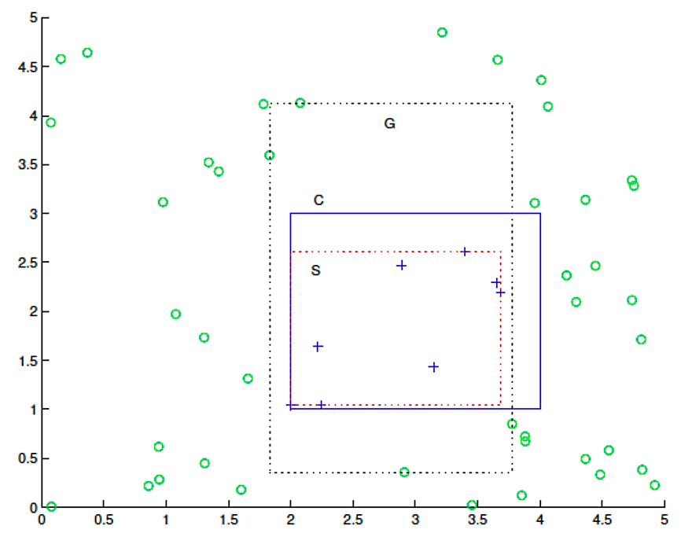

## Deliverables

Python source code, results, and relevant scatter plots to show hypotheses on training data and test data. Make a single PDF file and upload to LMS

# Solution

## Generation of Data Samples

import numpy as np

import matplotlib.pyplot as plt

from matplotlib.patches import Rectangle

*# Small tau value for adding spacing*

tau = 0.15

*# Generate positive samples*

positive_samples = np.random.uniform(

*low*=(2 + tau, 1 + tau), *high*=(4 - tau, 3 - tau), *size*=(20, 2)

)

*# Generate negative samples*

negative_samples = np.random.uniform(*low*=[0, 0], *high*=[5, 5], *size*=(80, 2))

*# Remove negative samples that are inside the positive region*

negative_samples = negative_samples[

    ~(

        (negative_samples[:, 0] > 2 - tau * 2)

        & (negative_samples[:, 0] < 4 + tau * 2)

        & (negative_samples[:, 1] > 1 - tau * 2)

        & (negative_samples[:, 1] < 3 + tau * 2)

    )

]

## Finding Strict (S) and General (G) Hypothesis

*# Find strict class boundary region from positive samples*

strict_min_x = np.min(positive_samples[:, 0])

strict_max_x = np.max(positive_samples[:, 0])

strict_min_y = np.min(positive_samples[:, 1])

strict_max_y = np.max(positive_samples[:, 1])

*# Find most general class boundary region from negative samples*

*# General class boundary is the extension of strict class boundary lines of each of the 4 sides until it hits a negative sample*

general_min_x = []

general_max_x = []

general_min_y = []

general_max_y = []

for sample in negative_samples:

    if (

        sample[0] > strict_min_x

        and sample[0] < strict_max_x

        and sample[1] > strict_max_y

    ):

        general_max_y.append(sample[1])

for sample in negative_samples:

    if (

        sample[0] > strict_min_x

        and sample[0] < strict_max_x

        and sample[1] < strict_min_y

    ):

        general_min_y.append(sample[1])

if not general_max_y == []:

    general_max_y = np.min(general_max_y)

else:

    general_max_y = strict_max_y

if not general_min_y == []:

    general_min_y = np.max(general_min_y)

else:

    general_min_y = strict_min_y

for sample in negative_samples:

    if (

        sample[1] > general_min_y

        and sample[1] < general_max_y

        and sample[0] > strict_max_x

    ):

        general_max_x.append(sample[0])

for sample in negative_samples:

    if (

        sample[1] > general_min_y

        and sample[1] < general_max_y

        and sample[0] < strict_min_x

    ):

        general_min_x.append(sample[0])

if not general_max_x == []:

    general_max_x = np.min(general_max_x)

else:

    general_max_x = strict_max_x

if not general_min_x == []:

    general_min_x = np.max(general_min_x)

else:

    general_min_x = strict_min_x

## Scatter Plots (Training Data ~ Estimation of {S, G} Hypothesis)

*# Plot positive and negative samples*

fig, ax = plt.subplots()

ax.scatter(

    positive_samples[:, 0], positive_samples[:, 1], *label*="Positive Samples", *marker*="+"

)

ax.scatter(

    negative_samples[:, 0], negative_samples[:, 1],

*label*="Negative Samples",

*facecolors*="none",

*edgecolors*="g",

)

*# Plot the strict class boundary region*

S = [strict_min_x, strict_min_y, strict_max_x, strict_max_y]

ax.add_patch(

    Rectangle(

        (strict_min_x, strict_min_y), strict_max_x - strict_min_x,

        strict_max_y - strict_min_y, *fill*=False, *lw*=0.75, *linestyle*="--",

*edgecolor*="r",

    )

)

ax.text(strict_min_x + 0.05, strict_max_y - 0.25, "S", *fontsize*=12, *color*="r")

*# Plot the general class boundary region*

G = [general_min_x, general_min_y, general_max_x, general_max_y]

ax.add_patch(

    Rectangle(

        (general_min_x, general_min_y), general_max_x - general_min_x,

        general_max_y - general_min_y, *fill*=False, *lw*=0.75, *linestyle*="--",

*edgecolor*="black",

    )

)

ax.text(general_min_x + 0.05, general_max_y - 0.25, "G", *fontsize*=12, *color*="black")

*# Plot the class boundary*

ax.add_patch(Rectangle((2, 1), 2, 2, *fill*=False, *edgecolor*="b", *lw*=1))

ax.text(2.05, 2.75, "C", *fontsize*=12, *color*="b")

ax.set_xlabel("x-axis")

ax.set_ylabel("y-axis")

ax.legend(*loc*="upper left")

ax.set_title("S and G Hypothesis Estimation")

plt.show()

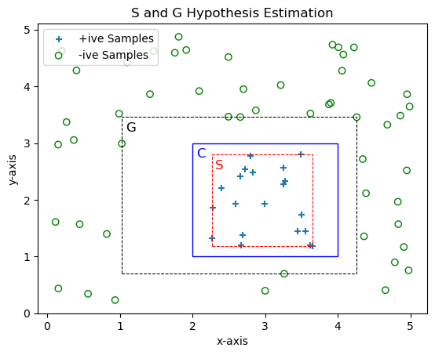

## Mapping Hypothesis to Test Data

*# Small tau value for adding spacing*

tau = 0.15

*# Generate positive samples*

test_positive_samples = np.random.uniform(

*low*=(2 + tau, 1 + tau), *high*=(4 - tau, 3 - tau), *size*=(15, 2)

)

*# Generate negative samples*

test_negative_samples = np.random.uniform(*low*=[0, 0], *high*=[5, 5], *size*=(60, 2))

*# Remove negative samples that are inside the positive region*

test_negative_samples = test_negative_samples[

    ~(

        (test_negative_samples[:, 0] > 2 - tau * 2)

        & (test_negative_samples[:, 0] < 4 + tau * 2)

        & (test_negative_samples[:, 1] > 1 - tau * 2)

        & (test_negative_samples[:, 1] < 3 + tau * 2)

    )

]

*# Compute the percentages*

positive_points_in_S = 0

negative_points_in_S = 0

positive_points_in_G = 0

negative_points_in_G = 0

for sample in test_positive_samples:

    if (

        sample[0] >= strict_min_x and sample[0] <= strict_max_x

        and sample[1] >= strict_min_y and sample[1] <= strict_max_y

    ):

        positive_points_in_S += 1

    if (

        sample[0] >= general_min_x and sample[0] <= general_max_x

        and sample[1] >= general_min_y and sample[1] <= general_max_y

    ):

        positive_points_in_G += 1

for sample in test_negative_samples:

    if (

        sample[0] >= strict_min_x and sample[0] <= strict_max_x

        and sample[1] >= strict_min_y and sample[1] <= strict_max_y

    ):

        negative_points_in_S += 1

    if (

        sample[0] >= general_min_x and sample[0] <= general_max_x

        and sample[1] >= general_min_y and sample[1] <= general_max_y

    ):

        negative_points_in_G += 1

print(

    "Percentage of positive points falling in S: ",

    positive_points_in_S / len(test_positive_samples),

)

print(

    "Percentage of negative points falling in S: ",

    negative_points_in_S / len(test_negative_samples),

)

print(

    "Percentage of positive points falling in G: ",

    positive_points_in_G / len(test_positive_samples),

)

print(

    "Percentage of negative points falling in G: ",

    negative_points_in_G / len(test_negative_samples),

)

*# Plot scatter plot of test samples*

fig, ax = plt.subplots()

ax.scatter(

    test_positive_samples[:, 0], test_positive_samples[:, 1],

*label*="Test +ive Samples", *marker*="+",

)

ax.scatter(

    test_negative_samples[:, 0], test_negative_samples[:, 1],

*label*="Test -ive Samples", *facecolors*="none", *edgecolors*="g",

)

*# Plot the strict class boundary region*

ax.add_patch(

    Rectangle(

        (strict_min_x, strict_min_y), strict_max_x - strict_min_x,

        strict_max_y - strict_min_y, *fill*=False, *lw*=0.75,

*linestyle*="--", *edgecolor*="r",

    )

)

ax.text(strict_min_x + 0.05, strict_max_y - 0.25, "S", *fontsize*=12, *color*="r")

*# Plot the general class boundary region*

ax.add_patch(

    Rectangle(

        (general_min_x, general_min_y), general_max_x - general_min_x,

        general_max_y - general_min_y, *fill*=False, *lw*=0.75,

*linestyle*="--", *edgecolor*="black",

    )

)

ax.text(general_min_x + 0.05, general_max_y - 0.25, "G", *fontsize*=12, *color*="black")

*# Plot the class boundary*

ax.add_patch(Rectangle((2, 1), 2, 2, *fill*=False, *edgecolor*="b", *lw*=1))

ax.text(2.05, 2.75, "C", *fontsize*=12, *color*="b")

ax.set_xlabel("x-axis")

ax.set_ylabel("y-axis")

ax.legend(*loc*="upper left")

ax.set_title("Test Samples")

plt.show()

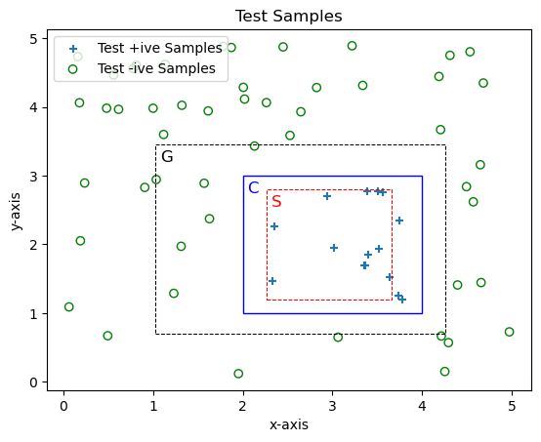

**Percentage Results**

Percentage of positive points falling in S:  80.0

Percentage of negative points falling in S:  0.0

Percentage of positive points falling in G:  100.0

Percentage of negative points falling in G:  12.0